Wireless Communication Systems Mid1, Nov 16, 2021

1. Explain the following terminologies in detail

(1) Frequency Division Duplex (FDD), use different frequency bands.

The transmitter (BS) and receiver (MS) operates at different carrier frequencies. FDD transmissions require a guard band between adjacent sub-bands (the transmitter and receiver frequencies)

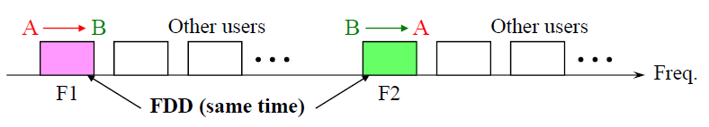

(2) Time Division Duplex (TDD), use different time-slots.

The uplink and downlink are separated by different time-slots in the same frequency band. TDD transmission requires a guard time (interval) between transmission and reception.

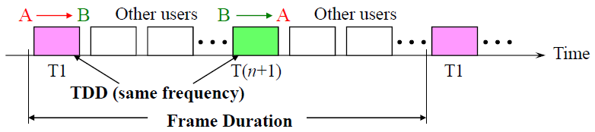

(3) Isotropic antenna

An isotropic antenna radiates equal signal power in both vertical and horizontal directions.

(4) Omni-directional antenna

An Omni-directional antenna radiates equal power only in horizontal direction, while the radiated power varying with elevation angle.

(5) Directional antenna

A directional antenna radiates the signal power in a specific direction.

(6) Half power beamwidth

The angular separation between the half power points on the antenna radiation pattern. The half power means the gain is half of the maximum value.

(7) Full Duplex

Two-way communications at any time instant.

A transmission approach that can support two-way transmissions using the same frequency band at the same time.

(8) Half Duplex

Two-way communications, only one-way at any time instant.

(9) Simplex

One-way communications

(10) Duplex

The communication capabilities between two connected devices that can communicate in both directions.

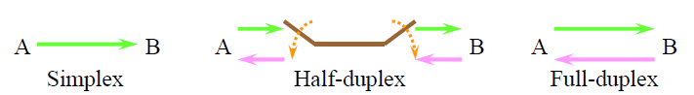

(11) Frequency Division Multiple Access (FDMA)

Divides a frequency band into multiple sub-bands. A guard band between two continuous sub-bands is required. No self-interference is introduced.

(12) Time Division Multiple Access (TDMA)

Divides a time interval (frame) into multiple time-slots. A guard time between two continuous time-slots is required. No self-interference is introduced.

(13) Code Division Multiple Access (CDMA)

Divide the spectral resources in the code domain. A set of low cross-correlation code is needed. Self-interference is introduced among different signals.

(14) Main lobe/Side lobe

Main lobe is the lobe that containing the higher power.

Side lobe are the lobes of the far field radiation pattern.

2. Show the frequency reuse planning with a frequency reuse factor N = 3, 4, and 7.

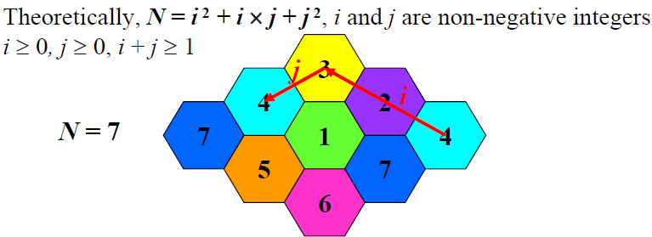

N = 3, (i, j) = (1, 1).

Each cell uses 1/3 of the total bandwidth. All channels are divided into 3 groups.

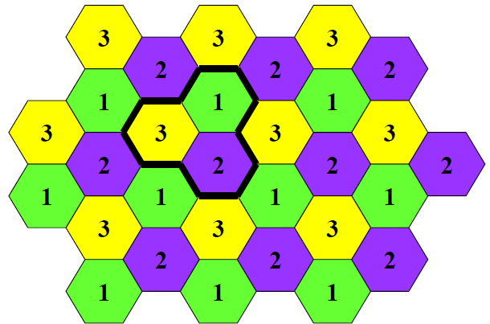

N = 4, (i, j) = (2, 0), (0, 2).

Each cell uses 1/4 of the total bandwidth. All channels are divided into 4 groups.

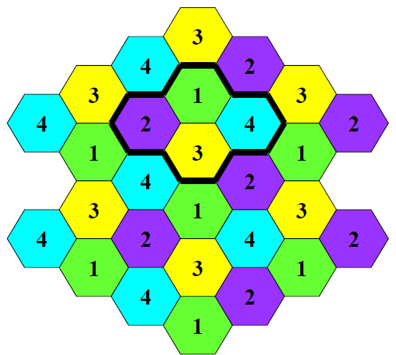

N = 7, (i, j) = (2, 1), (1, 2).

Each cell uses 1/7 of the total bandwidth. All channels are divided into 7 groups.

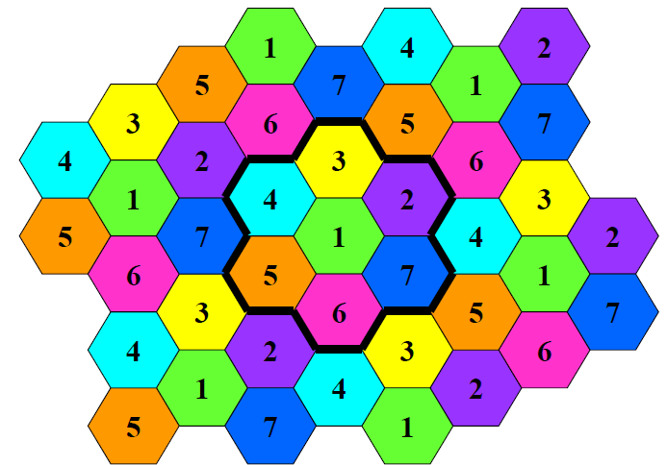

Co-channel reuse distance, the minimum distance between any two co-channel Base Station.

Co-channel BS, the BSs use the same frequency allocation.

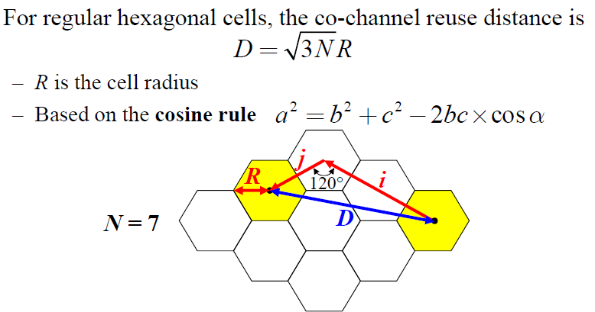

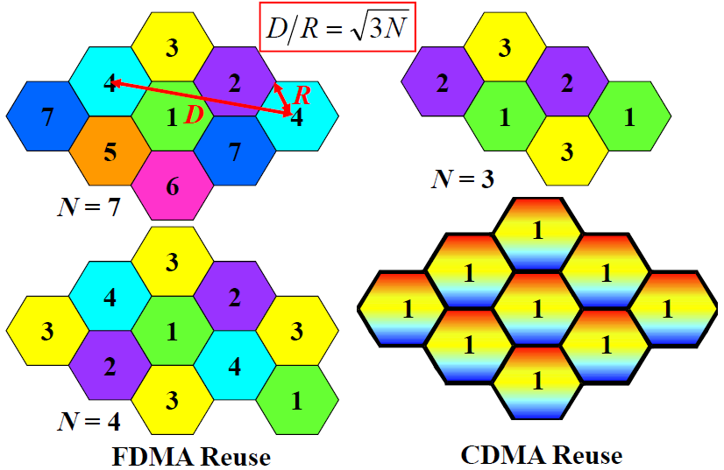

2.1 If the desired maximum Effective Isotropic Radiated Power (EIRP) is 30 dBW and a 40W power amplifier is used, determine the required antenna gain in dBd.

EIRP = Pt + Lc + Gi, dBi = dBd + 2.15

2.2 (a) No, because of increasing the transmission power also enhance the co–channel interference ⟹ Carrier–to–interference ratio didn’t change ⟹ Reuse factor also didn’t change

(b) Yes, because of increasing the transmission power ⟹ the link budget also increased ⟹cell coverage also increased.

(c) According to the formula, Nc = Wsys / (Wc ∙ N), where Nc is the number of channel per cell, N is the coverage area per cell (m^2), Wsys is the total system bandwidth (Hz), and Wc is the bandwidth per channel. ⟹ Set total system bandwidth Wsys, then bandwidths of FDMA = Wsys / (25 ∙ 4), TDMA = (Wsys / (200 ∙ 3)) ∙ 8, CDMA = (Wsys / (2 ∙1000)) ∙ 30 (unit of bandwidth is kHz) ⟹ FDMA : TDMA : CDMA = 6 : 8 : 9

(d) According to (a) Wsys ⟶20MHz, we can have Nc for each system. Nc_FDMA = 20 ∙ 1000 /25 ∙ 4 = 200, Nc_CDMA = 20 ∙ 1000 ∙ 8/200 ∙ 3 = 800/3, Nc_CDMA = 20 ∙ 1000 ∙ 20/2 ∙ 1000 = 300. The number of cells required for the systems are FDMA = 2 ∙ 10^5/200 = 10^3 cells, TDMA = 2 ∙ 10^5/(800/3) = 750 cells, CDMA = 2 ∙ 10^5/300 ≈ 667 cells.

3. The spectral efficiency of circuit switching systems can be expressed as , where is the bandwidth efficiency, is the is the spatial efficiency, and is the trunking efficiency.

(a) Define and propose two approaches to improve . What’s the related cost?

(b) Define and propose two approaches to improve . What’s the related cost?

(c) Define and explain the trade-off between and QoS (i.e. the blocking rate).

4. Consider a microcellular system, the desired outage probability for thermal noise on cell fringe is O(R) = 0.5. It is assumed that the propagation model is L(d) = 131 + 40log (d) dB with distance d in km, the channel bandwidth is 400kHz, the threshold of carrier-to-noise power ratio (CNR) is Γth = 5 dB, and the noise power spectral density at the receiver is – 160 dBm/Hz.

(a) Find the sensitivity (the minimum signal power that achieves Γth) of the receiver in dBm.

Formula: sensitivity = noise power spectral density + 10log (channel bandwidth) + CNR

(b) If the maximum output power is 56 dBm and the standard deviation (due to the shadowing effects) in CNR is σ_Ω = 8 dB, determine the cell radius. (Hint. O(R) = Q(μ – Γth(dB))/ σ_Ω)

(c) If the channel bandwidth is changed to 6.4 MHz, determine the cell radius.

(d) According to (c), if the cell radius obtained in (b) shall be maintained, determine the required maximum output power in dBm.

5. (a) If the desired maximum Effective Isotropic Radiated Power (EIRP) is 24 dBW and a 5W power amplifier is used, determine the required antenna gain in dBd. (Hint. The gain of a half-wave dipole antenna is 2.15 dBi.)

(b) According to (a), determine the maximum Effective Radiated Power (ERP) in dBW.

ERP = EIRP – 2.15

6. Consider two propagation environments with the corresponding delay spread 5 *μs* and 200 *ns*, respectively. Three systems are available with the channel bandwidth 100kHz, 1MHz, 10MHz, and the packet duration 10*ms*, 2*ms*, 0,5*ms*, respectively, operating in the 3GHz frequency band. There are three possible user velocities, including 5*m/s*, 20m/s, 60m/s.

(a) In what situations (delay spread, channel bandwidth / packet duration, and user velocities), the observed channel is frequency–selective or frequency–non–selective. Why?

(b) In what situations (delay spread, channel bandwidth / packet duration, and user velocities), the observed channel is time–variant or time­–invariant for the reception of a packet. Why?

(Hint. doppler spread fm = v / λc, c = fc ∙ λc)

7. Consider two multi–path fading channels with same average signal power, one is Rayleigh fading (channel A) and the other is Ricean fading (channel B). The level crossing rates of the envelope level *ρ* are denoted as L_R, A(*ρ*) and L_R, B(*ρ*), respectively.

(a) Compare the two level-crossing rates L_R, A(*ρ* = –5dB) and L_R, B(*ρ* = –5dB), and explain the reasons in detail.

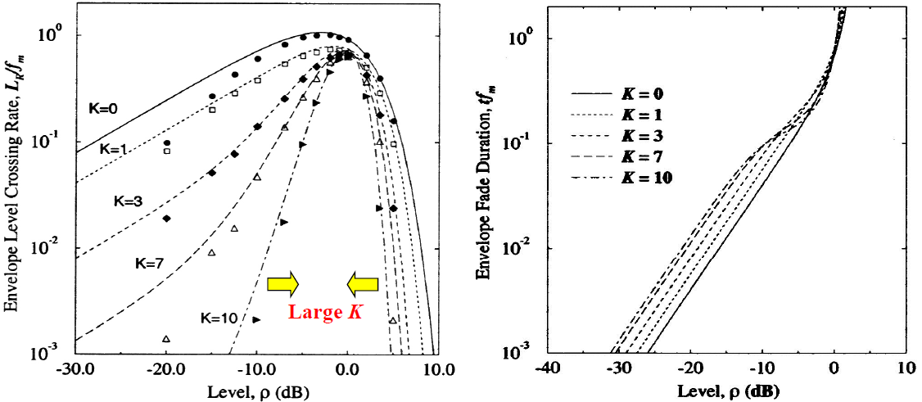

(b) Compare the average fade duration t_A(*ρ* = –5dB) and t_B(*ρ* = –5dB), and explain the reasons in detail.

(c) Compare the two level-crossing rates L_R, A(*ρ* = 5dB) and L_R, B(*ρ* = 5dB), and explain the reasons in detail.

(d) Compare the average fade duration t_A(*ρ* = –5dB) and t_A(*ρ* = 5dB), and explain the reasons in detail.

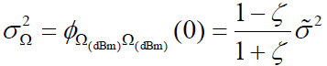8. The spatial correlation of the shadowing effect is modeled as a Guassian white noise process filtered with a first–order low–pass filter, i.e. *Ω_*k+1(dBm) = ξ ∙ *Ω_*k + (1 – ξ) ∙ *v_*k, where k is the location index, *Ω_*k is the received signal power, ξ is the spatial correlation of shadowing, and *v* is a zero–mean Gaussian random variable, variance *σ_v*^2. The variance of shadowing effect is assumed to be *σ*^2.

(a) Find the variance *σ_v*^2 in terms of *σ*^2.

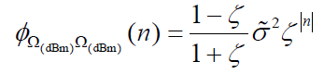(b) Show that the spatial autocorrelation function is

(c) Find d_cor.

(c) If an MS is traveling with velocity v, the envelope is sampled for every T seconds, and ξ_D is the shadow correlation of spatial distance D m, then the spatial correlation can be represented as

By contrast, in the ITV channel model, the spatial correlation is defined as *𝜙(∆x)* = *σ_*Ω^2 ∙ e^(–ln2|*∆x*| / d_cor). Find the parameter d_cor based on D and ξ_D.

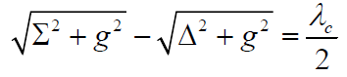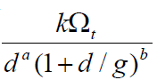9. The average received signal power of a channel can be expressed as where Ω_t is the transmission power, d is the propagation distance,

g is the break–point, and a, b, and k are const. related to the channel. The break–point g satisfies the relation where and with

respectively representing the antenna heights of BS and MS.

(a) Show that the channel has two–slope propagation loss (in dB scale) and find the two slopes.

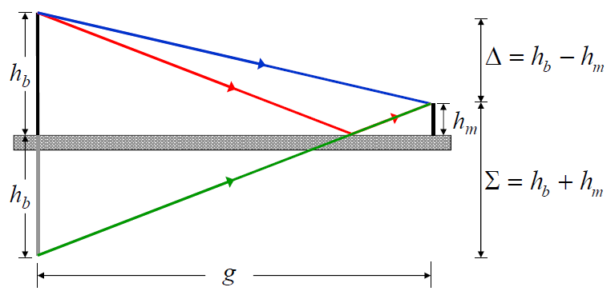

(b) Derive the break–point g.

(c) If the carrier frequency is high enough (i.e. λc ≪1), show that the break–point g can be approximated as g ≈

10. (Same as previous problem 2.2) Consider three mobile communication systems applying FDMA, TDMA, CDMA multiple access schemes. For the FDMA system, frequency reuse factor is 7 and channel bandwidth is 25 kHz. For the TDMA system, frequency reuse factor is 4 and channel bandwidth is 200kHz for supporting 8 users, while for the CDMA system, channel bandwidth is 1.2MHz for supporting 20 users.

(a) Can the cell coverage be extended via increasing the transmission power? Why?

⟹ Yes, increasing the transmission power also increase the carrier–to–noise ratio, so the coverage can be extended.

(b) Can the frequency reuse factor be reduced via increasing the transmission power? Why?

⟹ No, increasing the transmission power would enhance the co–channel interference, while the carrier–to–interference ratio remains the same, so the frequency reuse factor won’t be reduced.

(c) Compare the system capacity of the three systems for the same bandwidth resources.

(d) Assuming that the total available bandwidth is 16.8MHz and the whole services area requires a total of 150000 user channels, determine the number of cells required for the three systems.

11. Consider a communication system under a Rayleigh fading channel, the carrier frequency is 2GHz and a coding scheme with interleaving (the interleaving interval is assumed to be 5*ms*) is applied. Good radio link can be maintained for a normalized level *ρ* ≥0.1

(a) Find the level crossing rates and average fade duration for *ρ* = 0.1 with user mobility v = 72 and 4 *km/hr*.

(b) Dose the system perform well for v = 72 and 4 *km/hr*? Why?

(c) If the interleaving interval is now changed to 20 *ms*, dose the system perform well for v = 72 and 4 *km/hr*? Why?

(d) If an additional power margin of 14 dB is required (i.e. higher normalized level *ρ* is required) for a specific performance requirement, find the average fade duration for v = 72 and 4 *km/hr*. Dose the system perform well for v = 72 and 4 *km/hr*? Why?

12. The received signal power in free space can be represented as

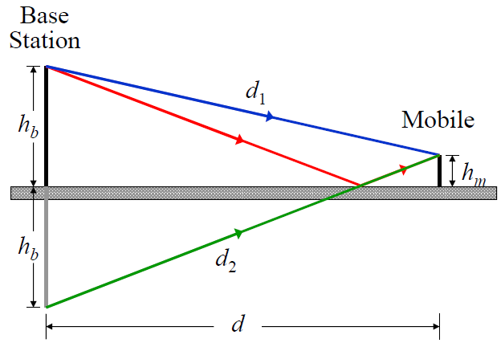In land mobile radio applications, it is assumed that the propagation is over a flat reflection surface as shown in Fig1. Please show that Pr is inversely proportional to d^4 for d ≫ (Hint. the reflection coefficient = –1, and *∆ϕ = 2π∆d/λc* is the phase difference of the two paths.

13. Some parameters are used to characterize a frequency–selective fading channel, including multipath intensity profile, Doppler spread, coherence bandwidth, and coherence time.

(a) Determine which parameter rely on the propagation environments, such as urban, suburban, or open area? Why?

⟹ multipath intensity profile (delay spread ), coherence bandwidth . ∝ 1/

Because with different environments, the multipath effect would be different as well. Therefore, delay spread depends on propagation environment. Moreover, coherence bandwidth is inverse to the delay spread, and thus depends on propagation environment either.

(b) Determine which parameter rely on user mobility? Why?

⟹ coherence time , Doppler spread . 1/

Because with different user mobility, the Doppler effect would be different as well. Therefore, Doppler spread depends on user mobility. Moreover, coherence time is inverse to the Doppler spread, and thus depends on user mobility.

14. For hexagon cells, show that D = R by using the law of cosine (cosine formula), where D is co–channel reuse distance, N is the frequency reuse factor, and R is the cell radius.

15. Consider a mobile communication system using a specific frequency band in specific environment.

(a) Is it possible for a receiver to reduce the experienced coherence time? Why?

(b) Is it possible for a receiver to reduce the experienced coherence bandwidth? Why?

(c) How to assure the experienced communication channel is frequency–non–selective (flat)?

(d) How to assure the experienced communication channel is frequency–selective (non–flat)?

16. (a) (b)

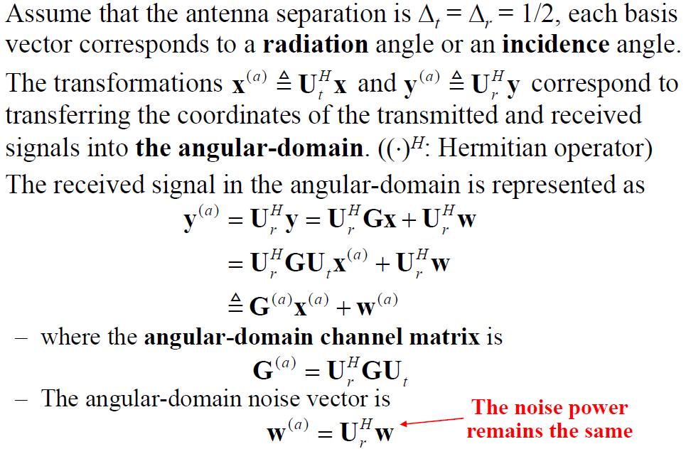

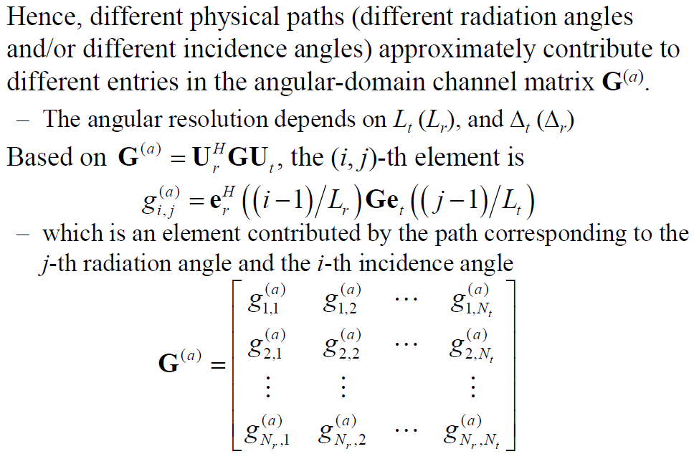

17. Definitions

(a) Delay spread

The difference between the time of arrival of the earliest significant multipath component and time of arrival of the last multipath component.

(b) Doppler spread

The range of frequencies over the received non–zero Doppler spectrum.

(c) Coherence time

The time duration over the non–varying channel impulse response.

(d) Coherence bandwidth

The bandwidth or frequency interval over two frequencies of a signal that are likely to experience comparable or corelated amplitude fading.

(e) Relationships among the four channel characteristics

Coherence time 1 / Doppler spread

Coherence bandwidth ∝ 1 / delay spread

18. Explain BS⟶MS, MS⟶BS, Microcellular system, Macrocellular system

(a) BS⟶MS in macrocellular system. Isotropic scattering

The MS in a microcellular environment is usually surrounded by many local scatterers so that there are a lot of reflection paths in different directions. The arriving plane waves arrive from all directions with equal probability. In general, no direct LOS path exist between MS and BS.

(b) MS⟶BS in macrocellular system. Not isotropic scattering

Usually, the BS in a microcellular environment is located at a high position and is relatively free from local scatterers. The arriving plane waves tends to arrive form one general direction

(c) Microcellular system

In a microcellular environment, the plane waves may be channeled by the buildings along the streets and arrive at the receiver from just one direction. The BS antenna only moderately elevated above the local scatterers. A direct LOS path may exist between the MS and the desired BS. So microcellular system is not isotropic scattering.

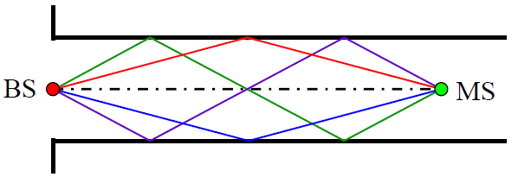

(d) Macrocellular system

At MS, the signals are isotropic scattered. For isotropic scattering, the spatial correlation decreases much faster than that of non–isotropic scattering.

At BS, the signals tend to be concentrated in a narrow angle of arrival which is non–isotropic scattering. The spatial correlation is higher than isotropic scattering.

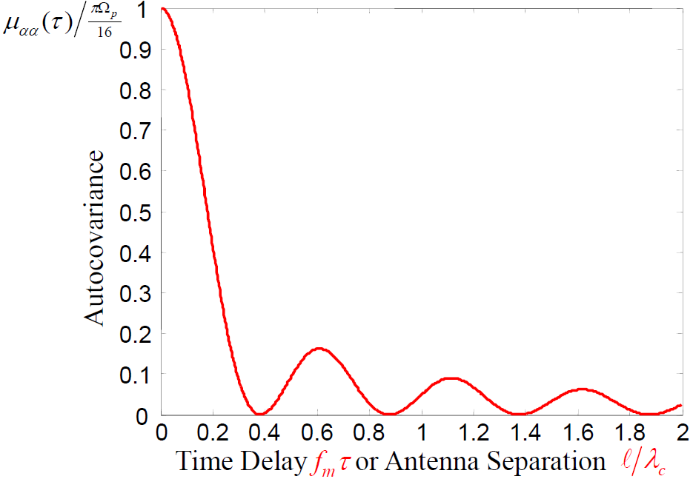

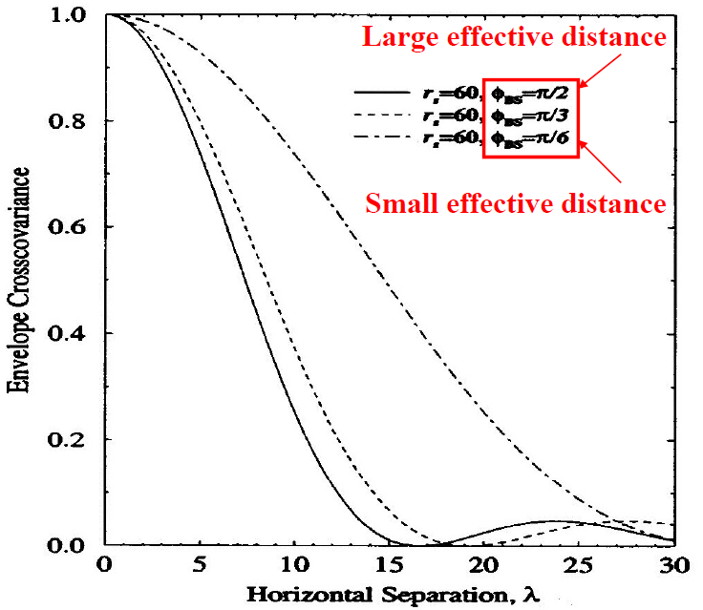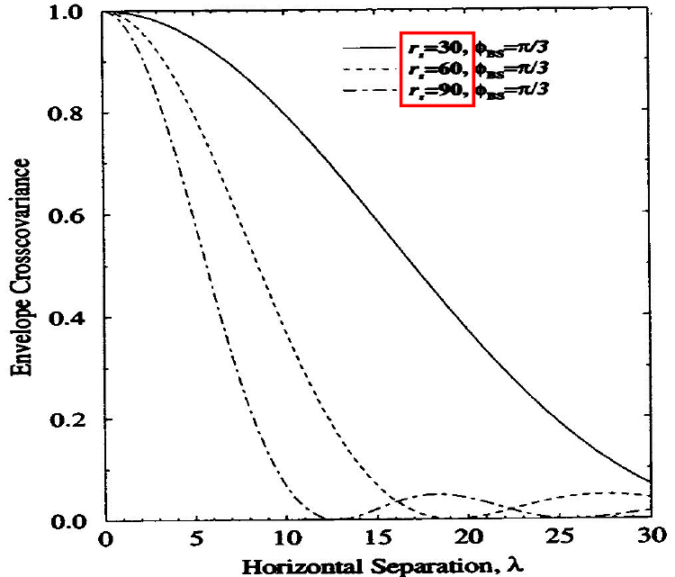

19.

(a)

(b)

(c)

20. Comparison between Frequency–selective and frequency–non–selective

21. Consider an antenna with gain 17 dBi. If the required output signal power is 29 dBW, determine the input signal power in W.